**Library management System**

**Index:**

1. **Introduction**
2. **Tables**

* **author**
* **book**
* **book_author**
* **book_copy**
* **borrower_acount**
* **category**
* **check_out**
* **hold**
* **notifications**
* **publisher**
* **wait_list**

1. **ER Diagram**
2. **SQL commands (Select, Update, Insert, Delete)**

**Introduction:**

The Database Library System is intended to Automate the library activities such as creating a new borrower, giving books to the borrowers, maintaining the details of all the item that were available in the books . This also helps the librarians by providing information such as total copies available each book, list of books that belong to a particular category.

**Tables:**

* Books, Authors and Book_Author:

As books are the core element in the library system, our database needs to contain information about them and their authors. The most intuitive way is to create two tables: book and author.

* To summarize, the table book will have the following columns:
* id: the unique identifier and the primary key.
* title: the title of the book.
* The table author will have the following columns:
* id: the unique identifier and the primary key.
* name: the name of the author.
* The table book_author will have the following columns:
* book_id: the id of the book.
* author_id: the id of the author.
* Categories:

In our library, each book is assigned to a category. A book may belong to only one category.

* We create a new table category. This table needs only two columns:
* id: the unique row identifier and the primary key.
* name: the name of the category, for example, "Adventure."
* Book Copies and Publisher:

Our library may have multiple copies of the same book. A book may also be published by multiple publishers. To model this, we create two tables: book_copy and publisher.

* The table publisher represents the publisher of the book. It consists of two columns:
* id: the unique row identifier and the primary key.
* name: the name of the publisher.
* The table book_copy has the following columns:
* id: the unique row identifier and the primary key.
* year_published: the year in which the book was published.
* book_id: a foreign key pointing to the corresponding row in the book
* publisher_id: a foreign key, the id of the publisher of the book in the table publisher.
* Borrower Accounts:

The book part is done. Now, we need people to check out our books! We need to store information about library books borrower, such as first name, surname, and email. Each member has his or her own library card and an account which may be active or blocked.

* We will use one table to store all this data: Borrower_Account. It consists of the following columns:
* card_number: the unique card number; it is also the primary key.
* first_name: the patron's first name.
* surname: the patron's last name.
* email: the borrower's email used for sending notifications.
* status: active or blocked.
* Checkouts and Holds:

We need a way for the borrowers to check out or place a hold on (i.e., reserve) specific books. We will store records of checkouts and holds in two tables: checkout and hold.

* The table checkout has the following columns:
* id: the unique row identifier and the primary key.
* start_time: the timestamp when the book is checked out.
* end_time: the timestamp when the book is returned.
* book_copy_id: the id of the book copy that has been checked out.
* borrower_account_id: the id of the borrower who has checked out the book.
* is_returned: a Boolean field indicating whether or not the book has been successfully returned.
* The table hold has the following columns:
* id: the unique row identifier and the primary key.
* start_time: the timestamp when the book is placed on hold.
* end_time: the timestamp when the hold ends. This is either when the hold expires or when the book has been checked out.
* book_copy_id: the id of the book copy that has been placed on hold.
* borrower_account_id: the id of the borrower who has placed the hold.
* Waiting List:

At times, all copies of a given book may be checked out or be on hold. The borrowers may want to be placed on a waiting list and get notified when it becomes available. We are going to create a table to save waiting list entries. Let's call it waitlist.

* This table will have only two columns:
* borrower_id: the id of the borrower who is checking out the book and not returned.
* book_id: a foreign key, the id of the book.
* Borrower_Acount_card_no: a foreign key, the id of the borrower who wishes to check out the book.
* Notifications:

Last but not least, we need to send notifications to our borrowers: to remind them a book should be returned or to let them know the book they have been waiting for is now available in the library.We need to create one additional table, notifications.

* This table will consist of the following columns:
* id: the unique row identifier and the primary key.
* sent_at: the timestamp when the notification is sent.
* type: the notification type. For now, it is either a reminder to return the book or a notification that a certain book is available. In the future, we may have more options here.
* Borrower_account_id: the ID pointing to the borrower to be notified by email.

**ER Diagram:**

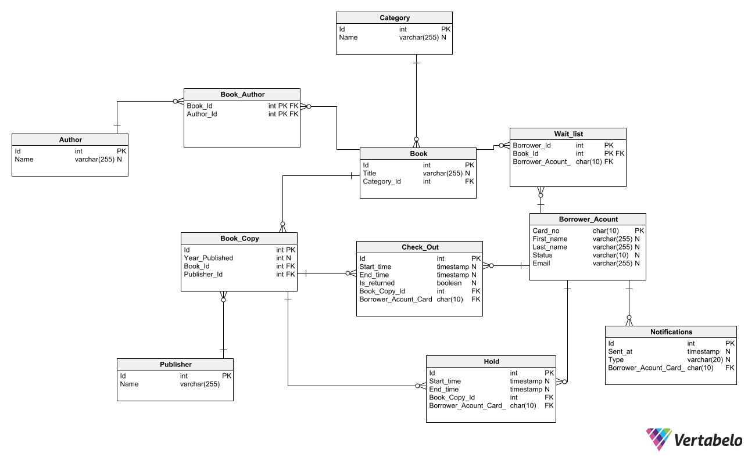

**SQL commands (Select, Update, Insert, Delete):**

-- Created by Vertabelo (http://vertabelo.com)

-- Last modification date: 2023-01-10 17:09:48.498

show databases

use librarymanagement

show tables;

-- tables

-- Table: Author

CREATE TABLE Author (

Id int NOT NULL,

Name varchar(255) NULL,

CONSTRAINT Author_pk PRIMARY KEY (Id)

);

-- Inserting data into Table: Author

Insert into Author Values(001, "R.N.Tagore");

Insert into Author Values(002, "Shakespeare");

Insert into Author Values(003, "Kalidas");

-- Check data in tables:

Select * from Author;

-- Table: Book

CREATE TABLE Book (

Id int NOT NULL,

Title varchar(255) NULL,

Category_Id int NOT NULL,

CONSTRAINT Book_pk PRIMARY KEY (Id)

);

-- Inserting data into Table: Book

Insert into Book Values(001,"Geetanjali",001);

Insert into Book Values(002,"The Merchant of Venice",002);

Insert into Book Values(003,"Chitra",002);

Insert into Book Values(004,"Shakuntala",002);

Insert into Book Values(005,"Bisarjan",002);

-- Check data in tables:

Select * from Book;

-- Table: Book_Author

CREATE TABLE Book_Author (

Book_Id int NOT NULL,

Author_Id int NOT NULL,

CONSTRAINT Book_Author_pk PRIMARY KEY (Book_Id,Author_Id)

);

-- Inserting data into Table: Book_Author

Insert into Book_Author Values(001,001);

Insert into Book_Author Values(002,002);

Insert into Book_Author Values(003,001);

Insert into Book_Author Values(004,001);

Insert into Book_Author Values(005,001);

-- Check data in tables:

Select * from Book_Author;

-- Table: Book_Copy

CREATE TABLE Book_Copy (

Id int NOT NULL,

Year_Published int NULL,

Book_Id int NOT NULL,

Publisher_Id int NOT NULL,

CONSTRAINT Book_Copy_pk PRIMARY KEY (Id)

);

-- Inserting data into Table:Book_Copy

Insert into Book_Copy Values(001,1913,001,001);

Insert into Book_Copy Values(002,1913,001,001);

Insert into Book_Copy Values(003,1596,002,002);

Insert into Book_Copy Values(004,1596,002,002);

Insert into Book_Copy Values(005,1913,003,001);

Insert into Book_Copy Values(006,1913,003,001);

Insert into Book_Copy Values(007,1791,004,001);

Insert into Book_Copy Values(008,1791,004,001);

Insert into Book_Copy Values(009,1912,005,001);

Insert into Book_Copy Values(010,1912,005,001);

-- Check data in tables:

Select * from Book_Copy;

-- Table: Borrower_Acount

CREATE TABLE Borrower_Acount (

Card_no char(10) NOT NULL,

First_name varchar(255) NULL,

Last_name varchar(255) NULL,

Status varchar(10) NULL,

Email varchar(255) NULL,

CONSTRAINT Borrower_Acount_pk PRIMARY KEY (Card_no)

);

-- Inserting data into table: Borrower_Acount

Insert into Borrower_Account Values(001,"Akshay","Kumar","Active","akshay@gmail.com");

Insert into Borrower_Account Values(002,"Bhushan","Dasar","Blocked","bhushan@gmail.com");

Insert into Borrower_Account Values(003,"Dinesh","Singh","Active","dinesh@gmail.com");

Insert into Borrower_Account Values(004,"Riya","Sharma","Blocked","riya@gmail.com");

Insert into Borrower_Account Values(005,"Sneha","Yadav","Active","sneha@gmail.com");

-- Check data in tables:

Select * from Borrower_Acount;

-- Table: Category

CREATE TABLE Category (

Id int NOT NULL,

Name varchar(255) NULL,

CONSTRAINT Category_pk PRIMARY KEY (Id)

) COMMENT 'In our library, each book is assigned to a category. A book may belong to only one category';

-- Inserting data into table: Category

Insert into Category Values(001,"Poetic");

Insert into Category Values(002,"Play");

Insert into Category Values(003,"Literature");

-- Check data in tables:

Select * from Category;

-- Table: Check_Out

CREATE TABLE Check_Out (

Id int NOT NULL,

Start_time timestamp NULL,

End_time timestamp NULL,

Is_returned boolean NULL,

Book_Copy_Id int NOT NULL,

Borrower_Acount_Card_no char(10) NOT NULL,

CONSTRAINT Check_Out_pk PRIMARY KEY (Id)

);

-- Inserting data into table:Check_Out

Insert into Check_Out Values(001,'2022-12-03','2023-01-10', True, 005,001);

Insert into Check_Out Values(002,'2022-12-08','2023-01-11', True, 006,005);

Insert into Check_Out Values(003,'2022-12-15','2023-01-05', True, 005,003);

Insert into Check_Out(Id, Start_time, Is_returned, Book_Copy_Id, Borrower_Acount_Card_no) Values(004,'2022-12-23', False, 005,001);

-- Updating data into table:

Update Check_Out set Book_Copy_Id = '008' where Id = '003';

Update Check_Out set Book_Copy_Id = '003' where Id = '001';

-- We can delete records using delete command

Delete from Check_Out where Id = '002'

-- Check data in tables:

Select * from Check_Out;

-- Table: Hold

CREATE TABLE Hold (

Id int NOT NULL,

Start_time timestamp NULL,

End_time timestamp NULL,

Book_Copy_Id int NOT NULL,

Borrower_Acount_Card_no char(10) NOT NULL,

CONSTRAINT Hold_pk PRIMARY KEY (Id)

);

-- Inserting data into table: Hold

Insert into Hold Values(001,'2022-12-03','2022-12-23',005,001);

Insert into Hold Values(002,'2022-12-05','2022-12-15',008,003);

Insert into Hold Values(003,'2022-12-10','2022-12-31',001,005);

-- Check data in tables:

Select * from Hold;

-- Table: Notifications

CREATE TABLE Notifications (

Id int NOT NULL,

Sent_at timestamp NULL,

Type varchar(20) NULL,

Borrower_Acount_Card_no char(10) NOT NULL,

CONSTRAINT Notifications_pk PRIMARY KEY (Id)

);

-- Inserting data into table: Notificatios

Insert into Notifications Values(001,'2022-12-14 10:42:13',"Book is available",003);

Insert into Notifications Values(002,'2022-12-22 13:40:13',"Book is available",001);

Insert into Notifications Values(003,'2023-01-10 09:23',"Rem: Return Book",001);

-- Check data in tables:

Select * from Notifications;

-- Table: Publisher

CREATE TABLE Publisher (

Id int NOT NULL,

Name varchar(255) NOT NULL,

CONSTRAINT Publisher_pk PRIMARY KEY (Id)

);

-- Inserting data into table: Publisher

Insert into Publisher Values(001, "R.N.Tagore");

Insert into Publisher Values(002, "Shakespeare");

Insert into Publisher Values(003, "Kalidas");

-- Check data in tables:

Select * from Publisher;

-- Table: Wait_list

CREATE TABLE Wait_list (

Borrower_Id int NOT NULL,

Book_Id int NOT NULL,

Borrower_Acount_Card_no char(10) NOT NULL,

CONSTRAINT Wait_list_pk PRIMARY KEY (Borrower_Id,Book_Id)

);

-- Inserting data into Tables: Wait_list

Insert into Wait_list Values(001,003,005);

-- Check data in tables:

Select * from Wait_list;

-- foreign keys

-- Reference: Book_Author_Author (table: Book_Author)

ALTER TABLE Book_Author ADD CONSTRAINT Book_Author_Author FOREIGN KEY Book_Author_Author (Author_Id)

REFERENCES Author (Id);

-- Reference: Book_Author_Book (table: Book_Author)

ALTER TABLE Book_Author ADD CONSTRAINT Book_Author_Book FOREIGN KEY Book_Author_Book (Book_Id)

REFERENCES Book (Id);

-- Reference: Book_Category (table: Book)

ALTER TABLE Book ADD CONSTRAINT Book_Category FOREIGN KEY Book_Category (Category_Id)

REFERENCES Category (Id);

-- Reference: Book_Copy_Book (table: Book_Copy)

ALTER TABLE Book_Copy ADD CONSTRAINT Book_Copy_Book FOREIGN KEY Book_Copy_Book (Book_Id)

REFERENCES Book (Id);

-- Reference: Book_Copy_Publisher (table: Book_Copy)

ALTER TABLE Book_Copy ADD CONSTRAINT Book_Copy_Publisher FOREIGN KEY Book_Copy_Publisher (Publisher_Id)

REFERENCES Publisher (Id);

-- Reference: Check_Out_Book_Copy (table: Check_Out)

ALTER TABLE Check_Out ADD CONSTRAINT Check_Out_Book_Copy FOREIGN KEY Check_Out_Book_Copy (Book_Copy_Id)

REFERENCES Book_Copy (Id);

-- Reference: Check_Out_Borrower_Acount (table: Check_Out)

ALTER TABLE Check_Out ADD CONSTRAINT Check_Out_Borrower_Acount FOREIGN KEY Check_Out_Borrower_Acount (Borrower_Acount_Card_no)

REFERENCES Borrower_Acount (Card_no);

-- Reference: Hold_Book_Copy (table: Hold)

ALTER TABLE Hold ADD CONSTRAINT Hold_Book_Copy FOREIGN KEY Hold_Book_Copy (Book_Copy_Id)

REFERENCES Book_Copy (Id);

-- Reference: Hold_Borrower_Acount (table: Hold)

ALTER TABLE Hold ADD CONSTRAINT Hold_Borrower_Acount FOREIGN KEY Hold_Borrower_Acount (Borrower_Acount_Card_no)

REFERENCES Borrower_Acount (Card_no);

-- Reference: Notifications_Borrower_Acount (table: Notifications)

ALTER TABLE Notifications ADD CONSTRAINT Notifications_Borrower_Acount FOREIGN KEY Notifications_Borrower_Acount (Borrower_Acount_Card_no)

REFERENCES Borrower_Acount (Card_no);

-- Reference: Wait_list_Book (table: Wait_list)

ALTER TABLE Wait_list ADD CONSTRAINT Wait_list_Book FOREIGN KEY Wait_list_Book (Book_Id)

REFERENCES Book (Id);

-- Reference: Wait_list_Borrower_Acount (table: Wait_list)

ALTER TABLE Wait_list ADD CONSTRAINT Wait_list_Borrower_Acount FOREIGN KEY Wait_list_Borrower_Acount (Borrower_Acount_Card_no)

REFERENCES Borrower_Acount (Card_no);

-- Questions:-

use librarymanagement

-- 1. How many borrowers are there in the dataset?

Select count(*) from Borrower_Acount;

-- 2. How many books is issued per card in the Check_out table?

Select distinct(Borrower_Acount_Card_no), count(Book_Copy_Id) from Check_Out group by Borrower_Acount_Card_no;

-- 3. Which book has highest number of borrowers?

-- select * from Check_Out;

-- Select * from Book;

-- Select * from Book_Copy;

-- Select Book_Copy_Id, Borrower_Acount_Card_no from Check_Out;

select distinct(B.Id) as Book_Id, Title, count(C.Id) as Copy_Id, count(Borrower_Acount_Card_no) as card_no from Book B left join Book_Copy C on B.Id=C.Book_Id left join Check_Out on Book_Copy_Id=C.Id group by B.Id;

-- 4. Which borrower has the maximum books?

Select distinct(Borrower_Acount_Card_No), count(Book_Copy_Id) from Check_Out group by Borrower_Acount_Card_No;

-- 5. Which borrower has not returned the book?Provide the book_copy_id which is yet to be return.

Select Borrower_Acount_Card_no, Book_Copy_Id from Check_Out where Is_returned= False;

-- 6. Which author wrote the maximum no of books?

Select A.Id as Author_Id, Name as Author_Name, count(Book_Id) from Author A left join Book_Author B on A.Id=B.Author_Id group by A.Id;

-- 7. Which category has the maximum number of books?

Select distinct(C.Id) as category_Id, Name as Category_Name, Count(B.Category_Id) from Category C left join Book B on C.Id=B.Category_Id group by C.Id;

-- 8. How many Notification has sent by the Libraray management System?

select count(*) from Notifications;

-- End of file.